CIS 490 Introduction to Computer Graphics

CIS 636 Computer Graphics

Spring 2011

Homework 3 (Problem Set)

Transformations and Viewing

Assigned: Mon 21 Feb 2011

Due: Mon 28 Feb 2011 (before midnight)

The purpose of this homework is to help you prepare for the first hour exam, by defining concepts, solving practice problems, and writing short essays on topics related to the polygons-to-pixels pipeline, particularly: TRS (translation, rotation, scaling) transformations, viewing, illumination, and shading.

This homework is worth a total of 30 points (3%).

Upload an electronic copy of the assignment in PDF form (converted from your word processor, or scanned) to your K-State Online (KSOL) drop box before the due date and time.

References

Viewing tutorial, I. Wachsmuth, Universität Bielefeld: http://bit.ly/dRrCyX (16, 21 – 23, 41 – 46)

VanDam notes, Brown: http://www.cs.brown.edu/courses/cs123/lectures.htm (Viewing I-III)

CG Basics 1 – 6, especially 2 and 4

Instructions and Notes (for the actual exam)

- You are permitted two (2) double-sided or four (4) single-sided, typewritten or handwritten pages of notes.
- No calculators or computing devices are needed or permitted on this exam.

- You should have a total of 6 pages; write your name on each page.
- There are five (5) problems. You have 75 minutes for this exam. Budget your time carefully.
- Circle which course number (490, 490, or 636) you are enrolled under, both on this page and for each question, and answer the questions for that course number.

- In the interest of fairness to all students, no questions shall be answered during the test concerning definitions.
- If you believe there is an error or ambiguity in any question, notify the instructor and state your assumptions.

- You may use any consistent naming system for vectors and coordinate systems. However, if it does not match the OpenGL conventions or the systems used in Eberly or Foley et al., then you are responsible for defining every vector by its full, unambiguous name.
- Use the space provided for your answers; you may add additional pages if needed.
- Select exactly one answer for each true/false and multiple choice question.
- Show your work on problems and proofs.
- There are a total of 100 possible points in this exam.

Instructor Use Only

- ______ / 20
- ______ / 20
- ______ / 20
- ______ / 20
- ______ / 20

Total ______ / 100

- Definitions (5 parts, 4% each, 20% total).

- Define: modelview transformation Specify and define the coordinate systems involved. What coordinate systems does it map between?

- (CIS 490 only) Define: parametric clipping (and differentiate it from Cohen-Sutherland clipping, with outcodes and simultaneous equations)
(CIS 636 & 736) Define: culling (give an example and differentiate it from clipping)

- Define: gluLookAt (in terms of input, output, and function)

- Define: fragment/pixel shading (give one example and differentiate it from vertex shading in terms of the light model)

- (CIS 490 & 636) Define: texture mapping
(CIS 736 only) Define: bump mapping (and explain briefly how it works)

- Short Answer (20%)

- (10%) Polygons-to-pixels pipeline. Draw an illustration of the polygons to pixels pipeline, including the following:

  - camera coordinates / eye coordinates
  - model coordinates / object coordinates
  - normalized device coordinates (NDC)
  - screen coordinates
  - (optional) view coordinates / clip coordinates
  - world coordinates / scene coordinates

Specify the order in which H_{proj}, H_{view}, H_{window}, and H_{world} go and what these have to do with the modelview transformation, normalizing transformation, perspective projection, perspective division, and viewport mapping. (Note: These are listed above in alphabetical order, not pipeline order!)

Also, explain exactly what coordinate systems the normalizing and viewing transformations map between and how they are applied to vertices of the scene.

- (10%) Types of mappings. Define each of the following mappings in a brief sentence, illustrating as needed:

        - Bump mapping

        - Displacement mapping

        - Reflection mapping

        - Shadow mapping

        - Transparency mapping

- Illustrating Concepts (4 parts, 5% each, 20% total). For the first two parts, fill in the boxes or blanks, and explain the filled-in value(s).

- (5%) 636 & 736: Phong illumination equation.

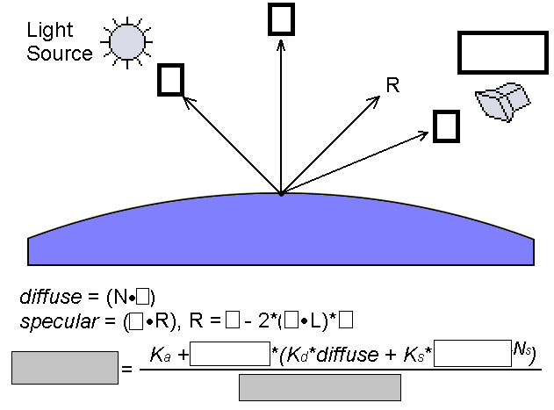

Define the left-hand side that you wrote in the left gray box above (especially how it is used) and explain the denominator (what it represents).

Additional space for 3a

- (5%) 490 only: clipping, intersection calculation. Fill in the blanks in the following figure and explain what the dot product’s relationship to 0 means. What does it mean to solve for t? Explain what the variable D = P₁ – P₀ denotes and what cross product is in the denominator of the formula (mathematical expression) for t, and for what values it is meaningful.

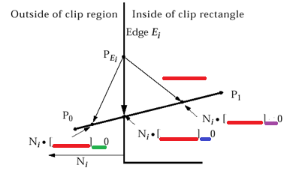

(5%) 636/736: scan line interpolation. Consider the following generic illustration of scan line interpolation of value v over a triangle where v₁, v₂, and v₃ are known, along with x₁, y₁, x₂, y₂, x₃, and y₃. Give the formulas for the three values being interpolated on each line: v_{a}, v_{b}, and v_{p}. Finally, list two quantities that can be interpolated and indicate when this happens.
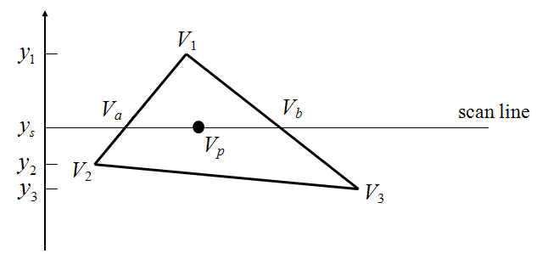

- (5%) 490/636: shading. What is the advantage of Gouraud shading over Phong shading? What is a disadvantage?

(5%) 736 only: view specification. What is the difference between a vertex shader and a pixel shader?

- (5%) CIS 490 only: Bresenham’s midpoint line drawing algorithm. How many symmetric cases are handled for line drawing, and why?

- (5%) CIS 636/736: perspective projections. Explain and illustrate one, two, and three-point perspective.

- Fill in the blank (5 parts, 4% each, 20% total).

- Rotation and translation are examples of ____________________ transformations while shear is not.

- (490/636) _____________________ is an affine transformation that is not linear.

(736) A surface that is ____________________ has a high diffuse albedo.

- ____________________ projections refer to all orthographic projections that are not aligned with one of the coordinate axes; a special case that is sometimes mistakenly used to refer to all such projections is called a(n) ____________________ projection.

- ____________________ is a(n) image-precision visible surface determination (VSD) technique.

- ____________________ is a kind of shading that has to be implemented at the fragment level (e.g., using the OpenGL Shading Language) instead of using glShadeModel().

- Short answer/definition (4 parts, 5% each, 20% total).

- Define rasterization (aka scan conversion) and name some objects other than line segments that computer graphics libraries tend to provide tools for scan converting.

- Explain the difference between illumination and shading.

- What is the halfway vector H for a point light source? How and why is it used in the Phong illumination equation? Illustrate your answer here, referring to Problem 3a.

- Consider the three arrays we discussed in lecture and which you used in homework to scan and represent a polygon mesh for an OpenGL function such as glDrawElements. Explain how the contents of these arrays are accessed based on the contents of others (and in what order they are organized).
.

Class Participation (required):

Post your full draft proposal, as specified in class, to CIS636-L by Fri 25 Feb 2011.

Ask any questions you have about Hour Exam 1 review material by class time Mon 28 Feb 2011.

