CIS 736
Computer Graphics

Spring, 2000

Midterm Exam (Closed-Book, Closed-Notes)
Friday, March 10, 2000

Instructions and notes

- Do not open this exam until instructed to.
- You have 100 minutes for this exam.
- You should have a total of 7 pages; write your name on each page.
- Use only the front side of pages for your answers; you may request additional pages if needed.
- Circle exactly one answer for each true/false and multiple choice question.
- Show your work on problems and proofs.
- No calculators or computing devices are needed or permitted on this exam.
- If you have questions, ask the instructor.
- There are a total of 150 possible points in this exam and 10 points of extra credit.

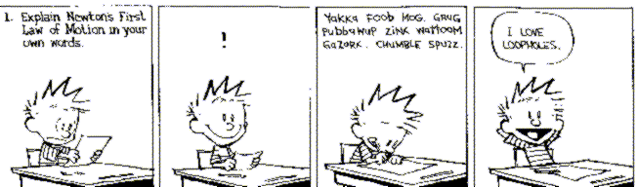

True/False (10 questions, 2 points each)

- T F

- T F

- T F

- T F

- T F

- T F

- T F

- T F

- T F

- T F
The canonical parallel projection view volume is a cuboid.

The normalizing transformation that takes the perspective-projection view volume into the parallel-projection canonical view volume occurs in 3D space.

The Liang-Barsky algorithm is a line clipping algorithm based on parametric intersection testing.

An Hermite curve has control polygons with 4 points each.

Interpolation of Bezier curves is generally faster than interpolation of comparable Hermite curves.

A quadtree node has neighbors in 4 possible directions.

A binary space partitioning (BSP) tree is a decision tree whose interior nodes classify points as lying inside, outside, or on a solid.

The CIE chromaticity diagram is independent of luminance (brightness).

(Hexagonal) slices through an HSV hexcone all have the same brightness (luminance).

Back-face culling and the depth-sort algorithm are examples of list-priority algorithms for visible-surface determination.

Multiple Choice (6 questions, 5 points each)

- Which of the following matrix transformations is not used in the perspective-projection normalizing transformation N_{per}?
- Translate
- Rotate
- Shear
- Scale
- All are used in N_{per}

- Which of the following clipping algorithms can be generalized from 2D to 3D?
  - Cyrus-Beck
  - Liang-Barsky
  - Cohen-Sutherland
  - I and II but not III
  - I, II, and III

- Which of the following is not a type of parallel projection?
- Oblique
- Orthographic
- Axonometric
- Isometric
- All of the above are parallel projections

- Which of the following states Euler's formula for simple polyhedra? (V = number of vertices, E = number of edges, F = number of faces)
- V + F + E = 2
- F - V - E = 2
- E - V + F = 2
- V + F - E = 2
- V - F + E = 2

- The perceptual term for excitation purity of a color is
- Hue
- Saturation
- Value
- Lightness
- Wavelength

- The Painter's Algorithm is a type of
- Conservative visible-surface determination
- Image-precision visible-surface determination
- Object-precision visible-surface determination
- View-volume clipping
- Spatial subdivision

Short Definition / Illustration (3 items, 10 points each)

- Define: frustum

Draw: perspective-projection canonical view volume construction (showing the following: near and far clipping planes, center of projection, view plane, and projectors)

- Define: Constructive Solid Geometry (CSG) tree

Draw: CSG tree for the object below

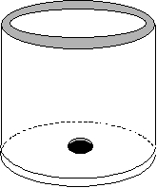

- Define: sweep representation

Draw: illustration showing how to generate a torus using a rotational sweep of a translated disk

Construction (30 points)

Construct a quadtree for the following 2D scene. Draw both the adaptive subdivision on the scene itself and the quadtree (showing full, partially full, and empty nodes) to a depth of 3 subdivisions. Use the quadrant numbering:

2 3
0 1

Derivation/Design (30 points)

Describe the Cohen-Sutherland 2D line clipping algorithm and give pseudocode for the outcode testing part only.

HINT: Recall that the Cohen-Sutherland algorithm is based on quick-rejection tests that are not necessarily conclusive. Describe the purpose of these tests, draw the outcode diagram, and write down the program logic for the test cases (specifically, when an intersection must be computed, and what intersection(s) must be computed).

Extra Credit

  - (5 points) Using the quadtree you drew in Problem 4, classify the points labeled A and B (show which leaf to which each point is mapped). Show your work here or on Problem 4, but write the resulting classifications here.

  - (5 points) Briefly explain deCasteljau’s subdivision algorithm for evaluation of a Bézier curve segment. Use an illustration if necessary.

